June
2019
Subtitle
I AM Elite Track & Field  Things will be, updated if anything changes happens. | 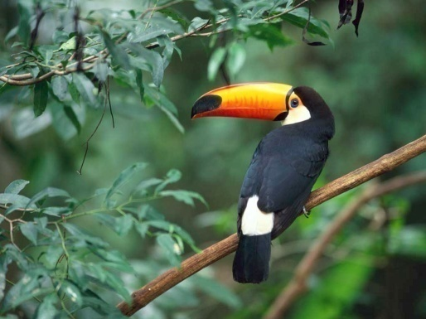
Sunday | Monday | Tuesday | Wednesday | Thursday | Friday | Saturday
 |  |  |  |  |  | 1
2 | 3 | 4 | 5 | 6 | 7 | 8
 | Training 6-8pm | Training 6-8pm | Training 6-8pm | Training 6-8pm
9 | 10 | 11 | 12 | 13 | 14 | 15
 | Training 6-8pm | Training 6-8pm | Training 6-8pm | Training 6-8pm |  | USATF Meet optional
16 | 17 | 18 | 19 | 20 | 21 | 22
USATF Meet optional | Training 6-8pm | Training 6-8pm | Training 6-8pm | Training 6-8pm |  | AAU Track Meet Prelims Sprints,  Long jump
23 | 24 | 25 | 26 | 27 | 28 | 29
AAU Track Meet Finals Sprints, Triple Jump | Training 6-8pm | Training 6-8pm | Training 6-8pm | Training 6-8pm |  | AAU Track Meet Prelims Sprints,  Long jump
30
AAU Track Meet Finals Sprints, Triple Jump
View and edit this document in Word on your computer, tablet, or phone. You can edit text; easily insert content such as pictures, shapes, and tables; and seamlessly save the document to the cloud from Word on your Windows, Mac, Android, or iOS device.

